Step Three:
Carry out and solve the following problems. Explain how each problem you solved is related to the Fibonacci numbers.

Fibonacci Brick Wall Patterns
The point of this activity is to see how many ways you can build a brick wall using the given amount of bricks.
- Each wall needs to be two units tall.
- Each brick standing on end is two units tall.
- Each brick laying on it's side is one unit tall.
- You are first given one, then two, three, etc.
- For one brick there is only one method of building a wall. Two methods for two, and three methods for three.
==========================================================
- How many ways are there to build a wall with four bricks, five, six?
- Make sure to show your sketches to prove your answer.
- How does the Fibonacci Series fit into this problem?
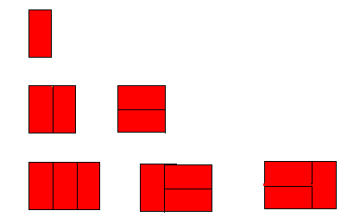


Fibonacci Bee Line
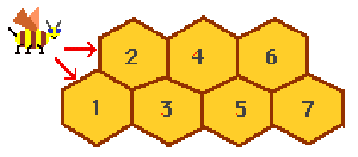
How many different ways can the bee reach the different numbers on the bee line?
- Set your answer up using a table. Go all the way up to number 7
Rules:
- The bee MUST start at either the 1 or 2.
- The bee can only go to higher numbers with each move.
- The bee can only move to the right.
Examples: To reach cell 1 the bee can only take one route. To reach cell 2 the bee can go directly to two or he can go from one to two.

Hive Number | Paths | Total
1 | 1 | 1
2 | 1-2, 2 | 2
3 | 1,1-2-3,

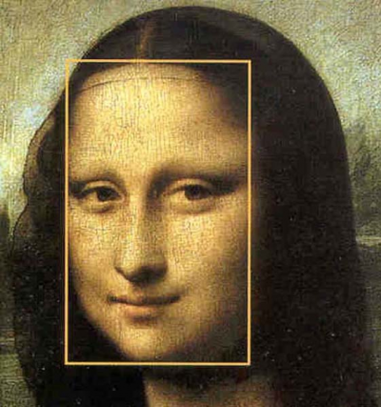
Bonus:
Crunch some numbers and play around with the golden ratio. Follow all directions when it comes to measuring yourself and the statue’s face. Neatly fill in the blanks

*BONUS*
Another pattern that pops up within the Fibonacci sequence is the golden ratio. If you divide any number in the sequence with the preceding number, you get a quotient somewhere around 1.6 something. Mathematicians call that number the golden ratio. It’s supposed to be pleasing to the eye. Many buildings, sculptures and paintings use the Golden Ratio for their dimensions. For example, the Mona Lisa uses the dimensions of the golden ratio. Grab a tape measure and use the following sheet to figure out if you have something in common with Mona Lisa.
Are You A Golden Proportion?
a. Navel to Chin_____ b. Length of Head_____ a/b_____
m. Navel to ground_____ n. Navel to Top-of-Head____ m/n_____
d. Knee to Sternum_____ e. Sternum to Top-of-Head_____ d/e_____
a. Navel to Chin_____ k. Top of leg to navel_____ a/k_____
g. Top of leg to sternum_____ h. Sternum to Chin_____ g/h_____
*Any unit of measurement will work for this*
If the number in the Calculate column is between 1.6-1.64 or close to that you are a golden proportion!
